Scenario #2: Sign In

# Description

This test scenario covers a user signing in to an existing, persisted user as well as tests

# Test Scripts

The following scripts will cover this scenario:

* 1.1. Valid Sign In
* 1.2. Invalid Username
* 1.3. Invalid Password

# Use Case

**1.6. Login**

When User

Wants to login to the system they click login and enter their account details

So that the User is authenticated and can perform actions that require authentication

# Test Components/Requirements

This test scenario covers the following high-level test requirements (see scripts below for specific requirements covered by each test script):

* Authentication
* Persistence

# User Groups

* Average user

# Script 1: Valid Sign In

## Description

* An unauthenticated user will visit a page of the site where the navigation bar is offered (currently all pages)
* Attempt to sign in with valid data
* Observe the result - The user should then be signed in

## Setup

* The testing user should ensure they are logged out
* The testing user should ensure the information from the data table is a valid user

|  |  |  |  |  |
| --- | --- | --- | --- | --- |
| **Step #** | **Test Step** | **Expected Test Results** | **P** | **F** |
| **1.** | Visit the site | Site loads with no errors |  |  |
| **2.** | Click “Sign In” in the top right | A modal window appears asking for registration details |  |  |
| **3.** | Fill in a valid set of details | No validation errors displayed |  |  |
| **4.** | Click “Sign In” in the modal window | The page refreshes and the username entered can be found in the top right as you are signed in |  |  |

|  |  |
| --- | --- |
| **Field Name** | **Data** |
| Username | shailesh |
| Password | Password |

|  |  |  |  |
| --- | --- | --- | --- |
| Date/Time | Tester | Test Phase | Status |
| 04/10/10 09:35 | Shailesh Jha | Alpha | Passed |

**Please refer to the screenshot below:**

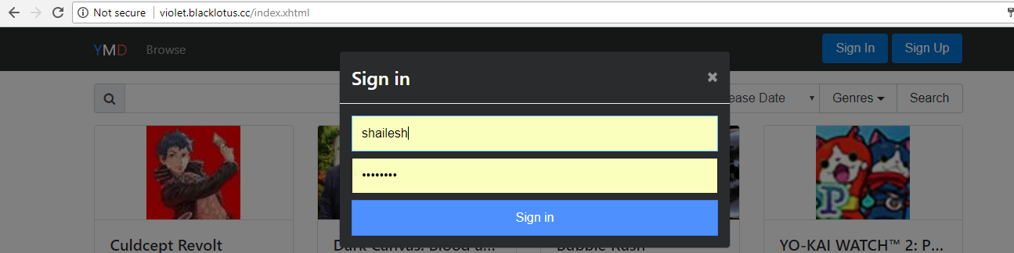

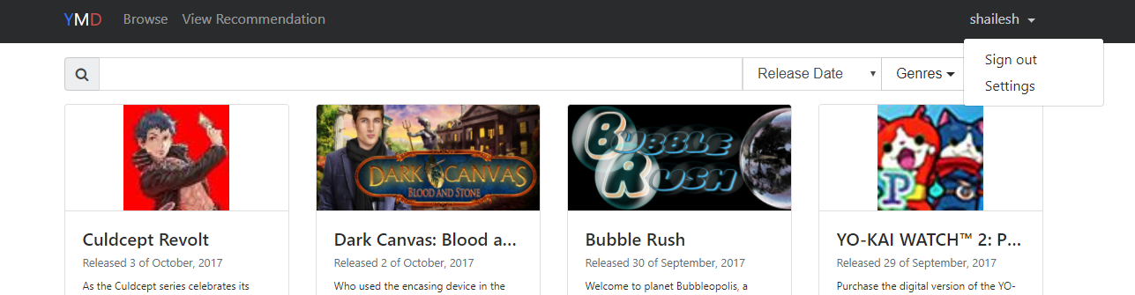

# Script 2: Invalid Username

## Description

* An unauthenticated user will visit a page of the site where the navigation bar is offered (currently all pages)
* Attempt to sign in with an invalid username
* Observe the result - The user should then be signed in

## Setup

* The testing user should ensure they are logged out
* The testing user should ensure the information from the data table is from a valid user

|  |  |  |  |  |
| --- | --- | --- | --- | --- |
| **Step #** | **Test Step** | **Expected Test Results** | **P** | **F** |
| **1.** | Visit the site | Site loads with no errors |  |  |
| **2.** | Click “Sign In” in the top right | A modal window appears asking for registration details |  |  |
| **3.** | Fill in a valid set of details |  |  |  |
| **4.** | Click “Sign In” in the modal window | A validation error is displayed and the user is not signed in |  |  |

|  |  |
| --- | --- |
| **Field Name** | **Data** |
| Username | crazyfrog |
| *Password* | *asd123* |

|  |  |  |  |
| --- | --- | --- | --- |
| Date/Time | Tester | Test Phase | Status |
| 04/10/17 09:42 | Shailesh Jha | Alpha | Passed |

**Please refer to the screenshot below:**

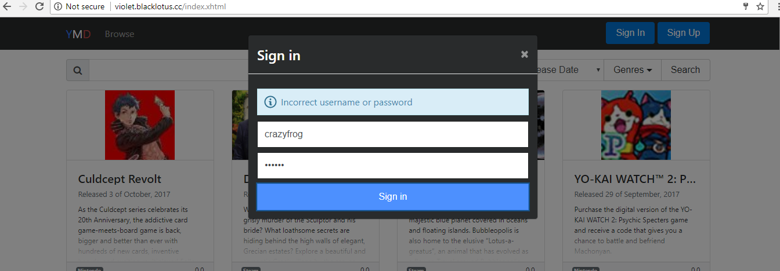

# Script 3: Invalid Password

## Description

* An unauthenticated user will visit a page of the site where the navigation bar is offered (currently all pages)
* Attempt to sign in with a valid username but invalid password
* Observe the result - The user should then be signed in

## Setup

* The testing user should ensure they are logged out
* The testing user should ensure the information in italics from the data table is from a valid user

|  |  |  |  |  |
| --- | --- | --- | --- | --- |
| **Step #** | **Test Step** | **Expected Test Results** | **P** | **F** |
| **1.** | Visit the site | Site loads with no errors |  |  |
| **2.** | Click “Sign In” in the top right | A modal window appears asking for registration details |  |  |
| **3.** | Fill in a valid set of details |  |  |  |
| **4.** | Click “Sign In” in the modal window | A validation error is displayed and the user is not signed in |  |  |

|  |  |
| --- | --- |
| **Field Name** | **Data** |
| *Username* | *shailesh* |
| Password | asd123 |

|  |  |  |  |
| --- | --- | --- | --- |
| Date/Time | Tester | Test Phase | Status |
| 04/10/17 09:52 | Shailesh Jha | Alpha | Passed |

**Please refer to the screenshot below:**

